

MISR UNIVERSITY FOR SCIENCE & TECHNOLOGY FACULTY OF ENGINEERING DEPARTMENT OF MECHATRONICS

**Proposal for ADAS Graduation Project**

**Submitted by.**

|  |  |
| --- | --- |
| **Abanob Malak** | **95689** |
| **Kareem Ahmed** | **95635** |
| **Omar Moselhy** | **95668** |
| **Magdy Maged** | **91672** |
| **Essam Alaa** | **91679** |

**Supervised by**

**Dr. Bahaa Eldin Mohamed**

**Table of Contents..**

1-Abstract

2-Introduction

3-Literature Review

4- Proposed Solution

5- Expected Outcomes

6- Conclusion

**Abstract**

Advanced Driver Assistance Systems (ADAS) signify a significant leap forward in automotive innovation, with the primary objective of improving vehicle safety and enriching the driving experience. This abstract examines the essential elements, operational features, and advantages of ADAS. By employing a diverse array of sensors, cameras, and radar technologies.

ADAS seeks to achieve its overarching aim of decreasing accident rates, curtailing human errors, and enhancing road safety. The advantages of ADAS are not limited to safety enhancements; they also include the provision of real-time information and support to drivers, which helps alleviate cognitive demands, thereby increasing comfort and reducing fatigue. Furthermore, as these systems advance, they are instrumental in establishing the groundwork for future autonomous driving technologies. Our Project is specifically handling the following features:

1- Bump Detection

2- Precise Lane Tracking

3- Traffic sign Recognition

4- Blind Spot Detection

5- Adaptive Cruise Control

6- Automatic Emergency Braking.

**1. Bump Detection:**  
 - Implementation of sensors and machine learning algorithms to detect road bumps and irregularities. The system will alert the driver in real-time, enabling them to take precautionary measures, thereby reducing the risk of vehicle damage and ensuring a smoother driving experience.  
  
**2. Precise Lane Tracking:** - Utilizing camera-based vision systems and algorithms to accurately track lane markings on the road. This system will alert drivers when the vehicle is unintentionally drifting out of its lane, helping to prevent accidents caused by driver inattention or fatigue.  
  
**3. Road Sign Interpretation:**  
 - The integration of image recognition technology to identify and interpret traffic signs. This system will display relevant traffic information on the vehicle's dashboard, ensuring that the driver is always informed about speed limits, no-entry zones, and other critical road signs.  
  
**4. Blind Spot Detection:** - Deployment of sensors and cameras to monitor areas around the vehicle that are typically difficult for the driver to see. The system will provide visual or auditory warnings when another vehicle is detected in the blind spot, helping to avoid collisions during lane changes.  
  
**5. Adaptive Cruise Control:** - Developing a system that automatically adjusts the vehicle’s speed to maintain a safe distance from the vehicle ahead. This feature not only enhances driving comfort but also contributes to overall road safety by reducing the likelihood of rear-end collisions.  
  
**6. Automatic Emergency Braking:**  
 - Implementation of a system that uses sensors to monitor the road ahead for potential collisions. If a hazard is detected and the driver does not respond in time, the system will automatically apply the brakes to prevent or mitigate the impact.

**Introduction**

A driver is one of the “best sensors in the vehicle” and is the main responsible for avoiding crashes. But still, a large proportion of crashes are attributed to driver errors. A survey was conducted to identify the critical reason for each crash, and the national sample of US crashes from 2005 to 2007 was examined . It was noted

that the driver error was the critical reason contributing to 94% of crashes as shown in Fig. 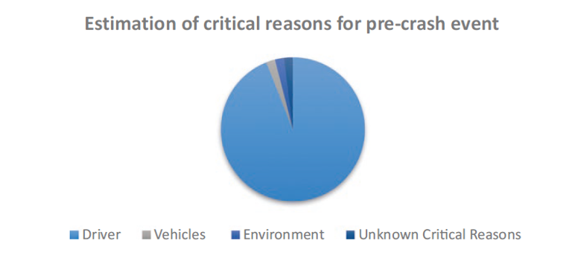

These errors included recognition errors, decision errors, performance errors, and nonperformance errors. Recognition errors are the result of inattention and inadequate surveillance of the driver; decision errors arise due to the misjudgments of the driver; performance errors arise due to overcompensation, poor directional control, etc.; and nonperformance errors arise due to sleeping and

fatigue

The development and deployment of the new in-vehicle technologies to counteract these driver errors and hence to support the driver to prevent crashes is ongoing. Advanced driver assistance systems (ADAS) are a group of vehicle technologies that warn the drivers timely regarding the risky or hazardous situations to avoid crashes. Some ADAS technologies actively and automatically intervene to avoid hazardous situations or when the system detects that a crash is imminent. ADAS technologies are the precursor to autonomous vehicles and, depending on the combination of ADAS equipment installed in a vehicle, can allow level 1 to level 2 autonomous driving at the present time as represented in Fig.

(SAE International 2014).

**How Does ADAS Work?**

Automobiles are the foundation of the next generation of mobile-connected devices, with rapid advances being made in autonomous vehicles. Autonomous application solutions are partitioned into various chips, called [systems on a chip (SoCs)](https://www.synopsys.com/implementation-and-signoff.html). These chips connect sensors to actuators through interfaces and high-performance electronic controller units (ECUs)…

Self-driving cars use a variety of these applications and technologies to gain 360-degree vision, both near (in the vehicle’s immediate vicinity) and far. That means hardware designs are using more advanced process nodes to meet ever-higher performance targets while simultaneously reducing demands on power and footprint.

**Expected Outcomes**

1] Giving the graduate student an opportunity to apply what he has learned and implement it in his specific field of specialization.

[2] Giving the student an opportunity to practice and apply professional ethics and work within the team before joining the work.

[3] Providing the opportunity to invest and find a sponsor for the project idea and implement it in practical applications.

[4] Qualifying the graduate student to be an effective element in all scientific and research fields.

[5] Ensure that the graduate student can utilize his practical abilities, cognitive structures, and writing, research, and documentation abilities during his studies.

**Risk Management**

**• Technical Risks:**

1- Hardware/Software Failures: Issues with sensors, cameras, or other hardware components.

2-Challenges: Problems when combining various ADAS modules.

3-Algorithm Accuracy: Risks related to the performance of algorithms, such as object detection or path planning.

**• Operational Risks:**

1-Project Delays: Risks associated with delays in development, testing, or procurement of components.

2-Resource Constraints: Limited access to necessary tools, technologies, or expertise.

**• External Risks:**

1- Regulatory Changes: Changes in automotive safety standards or regulations.

1. Market Dynamics: Shifts in industry trends that could affect project relevance or requirements.

**Conclusion**

In conclusion, advanced driver assistance systems (ADAS) have significantly contributed to enhancing car movement safety and improving overall driving experiences. The integration of blind-spot detection systems has effectively reduced the occurrence of accidents caused by lane changes, particularly in scenarios where drivers may have limited visibility. Lane departure systems have proven valuable in preventing unintentional drifts from lanes and reducing the risk of collisions due to driver inattentiveness or fatigue. Traffic sign recognition systems have played a crucial role in improving compliance with traffic regulations. By accurately identifying and displaying relevant traffic signs, these systems help drivers stay informed and make better decisions while on the road.

Overall, the advancements in ADAS technologies have demonstrated their effectiveness in preventing accidents, reducing human error, and enhancing overall road safety. As these systems continue to evolve, they have the potential to significantly reduce the number of collisions and make driving experiences safer and more enjoyable for everyone on the road.